Overview
This mini-assessment illustrates important content spanning multiple domains in grade 5 and draws on problem solving capacities developed in grades K–4. This mini-assessment is designed for teachers to use either in the classroom, for self-learning, or in professional development settings to:
- Evaluate students’ ability to solve real-world and mathematical problems with grade-appropriate content;
- Gain knowledge about assessing applied problem solving at the depth expected at grade 5; and
- Illustrate CCSS-aligned assessment problems.

Making the Shifts
This mini-assessment attends to focus as it addresses content spanning several clusters within the Number and Operations in Base Ten (NBT), Number and Operations—Fractions (NF), and Measurement and Data (MD) domains. These are all key components of the major work of grade 5. It addresses coherence across grades by drawing on the problem solving work of grades K–4 using the four operations. It sets the stage for solving multistep problems using the full system of rational numbers (e.g., negative integers). This mini-assessment targets application, one of the three elements of rigor, through word problems.
5.NBT.A: Understand the place value system.
5.NBT.B: Perform operations with multi-digit whole numbers and with decimals to hundredths.
5.NF.A: Use equivalent fractions as a strategy to add and subtract fractions.
5.NF.B: Apply and extend previous understandings of multiplication and division to multiply and divide fractions.
5.MD.A: Convert like measurement units within a given measurement system.
5.MD.C: Geometric measurement: understand concepts of volume and relate volume to multiplication and to addition.
5.G.A: Graph points on the coordinate plane to solve real-world and mathematical problems.
A Closer Look
This mini-assessment centers on applications of math in the grade 5 standards. For example, problem 6 is aligned to a standard that mentions solving word problems. Another example is problem 5, spanning two or more domains, in which students solve a word problem using calculation skills detailed in 5.NBT. The problems students encounter in this mini-assessment highlight topics such as place value understanding, the four operations on fractions, and volume, in order to illustrate connections across domains.

This mini-assessment as a whole is considered multi-domain. Due to the variety of content on this mini-assessment, teachers should use it toward the end of the year – as a measure of the cumulative knowledge and skills from K–5. This mini-assessment is not meant to be comprehensive, but rather offers a representative sampling of the types of questions on integrated content a fifth grade student should be able to do towards the end of the school year.
Name: Date:

- A store owner ordered 24 packages of candy. Each package contains 72 candies. He plans to make bags of candy with 18 candies in each bag and sell them near the cash register.
  - How many candies did the store owner order?

  - How many bags of candy can he make?

- Below are the dimensions of four stamps, in inches. Order the stamps below from greatest area to least area.

A B C D
$\frac{3}{4}×\frac{3}{4}$ $\frac{5}{8}×\frac{5}{8}$ $\frac{3}{4}×1\frac{1}{4}$ $1\frac{1}{4}×1\frac{1}{4}$

Greatest Least

- Callan has $\frac{1}{3}$ of his birthday cake left. He wants to share it equally between himself and 3 other boys. How much of the original birthday cake will each of the 4 boys get?

- Evelyn challenged the students in her grade to collect nickels for the entire school year. There are 37 students in her grade.
Each student collected 265 nickels. What is the total amount of money that the students collected?

- The diagram below represents a swimming pool with dimensions in feet. When the pool is filled with water, how many cubic feet of water are used to fill the pool all the way to the top?

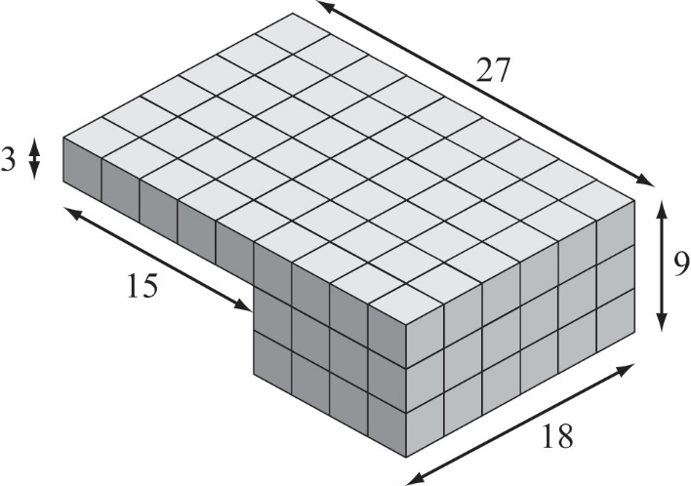

- Giant anacondas can reportedly grow up to 33 feet long. How many inches long is this?

- Jasmine is walking to her friend’s house, which is $2\frac{3}{4}$ miles away. She is $\frac{2}{3}$ of the way there. How much farther, in miles, does Jasmine have to walk?

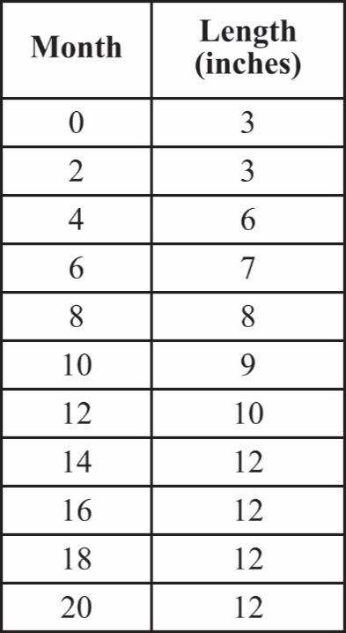
- The data table to the right shows the height of a typical meerkat at different times during their first 20 months of life.

- Graph the data on the grid below.



- How many inches did the meerkat grow between month 6 and month 18?
- How many months did it take for the meerkat to grow from 7 inches to 12 inches?
- Decide whether the meerkat grew more from month 0 to month 10 or from month 10 to month 20. Explain your answer.

Name: Date:

- A store owner ordered 24 packages of candy. Each package contains 72 candies. He plans to make bags of candy with 18 candies in each bag and sell them near the cash register.
  - How many candies did the store owner order?

24 × 72 = 1,728 candies

  - How many bags of candy can he make?

1,728 ÷ 18 = 96 bags of candy

- Below are the dimensions of four stamps, in inches. Order the stamps below from greatest area to least area.

A B C D
$\frac{3}{4}×\frac{3}{4}$ $\frac{5}{8}×\frac{5}{8}$ $\frac{3}{4}×1\frac{1}{4}$ $1\frac{1}{4}×1\frac{1}{4}$

D C A B
Greatest Least

Note: Students need not perform the computations here; they should be able to order the stamps based on the size of the factors.

- Callan has $\frac{1}{3}$ of his birthday cake left. He wants to share it equally between himself and 3 other boys. How much of the original birthday cake will each of the 4 boys get?
$$\frac{1}{3}÷4=\frac{1}{12}$$
$\frac{1}{12}$ of the original cake

- Evelyn challenged the students in her grade to collect nickels for the entire school year. There are 37 students in her grade.
Each student collected 265 nickels. What is the total amount of money that the students collected? $490.25
Method 1: find total # nickels first Method 2: find individual dollar amount first
265 × 37 = 9805 total nickels 265 ÷ 20 = $13.25 each student collects
9805 ÷ 20 = $490.25 total collected $13.25 × 37 = $490.25 total collected
Method 3: find the total value of cents in nickels and divide by 100.
265 x 37 = 9805 total nickels
9805 x 5 = 49025 total cents in nickels
49025 ÷ 100 = $490.25 total collected

- The diagram below represents a swimming pool with dimensions in feet. When the pool is filled with water, how many cubic feet of water are used to fill the pool all the way to the top?
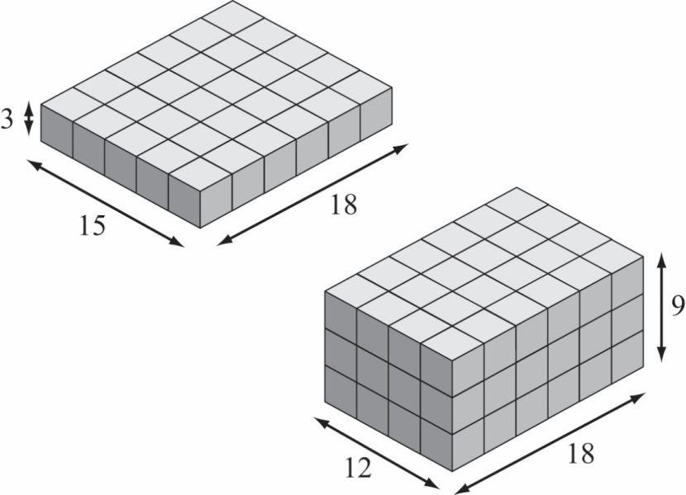

Method 1: divide into two rectangular prisms (3×15×18 and 9×12×18)
First portion: 3 × 15 × 18 = 810 cubic feet
Section portion: 9 × 12 × 18 = 1,944 cubic feet
Total volume: 810 + 1,944 = 2,754 cubic feet

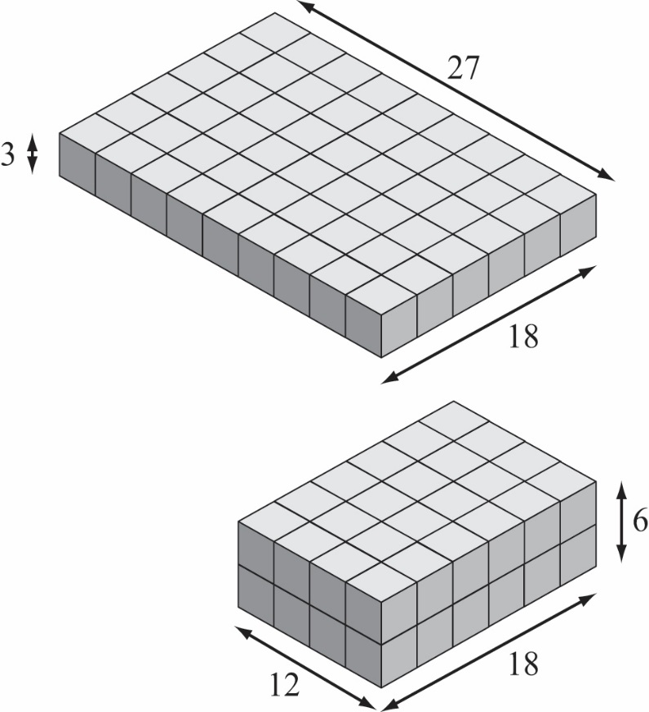

Method 2: divide into two rectangular prisms (3×27×18 and 6×12×18)
First portion: 3 × 27 × 18 = 1,458 cubic feet
Second portion: 6 × 12 × 18 = 1,296 cubic feet
Total volume: 1,458 + 1,296 = 2,754 cubic feet

- Giant anacondas can reportedly grow up to 33 feet long. How many inches long is this?
33 × 12 = 396 inches

- Jasmine is walking to her friend’s house, which is $2\frac{3}{4}$ miles away. She is $\frac{2}{3}$ of the way there. How much farther, in miles, does Jasmine have to walk?

Method 1:
$\frac{2}{3}×2\frac{3}{4}=\frac{2}{3}×\frac{11}{4}=\frac{22}{12}$ miles. This is the distance Jasmine has already walked.
$2\frac{3}{4}-\frac{22}{12}=\frac{11}{4}-\frac{22}{12}=\frac{33}{12}-\frac{22}{12}=\frac{11}{12}$ miles farther for Jasmine to go.

Method 2:
$\frac{1}{3}×2\frac{3}{4}=\frac{1}{3}×\frac{11}{4}=\frac{11}{12}$ miles farther for Jasmine to go.

- The data table to the right below shows the height of a typical meerkat at different times during the first 20 months of life.

- Graph the data on the grid below.
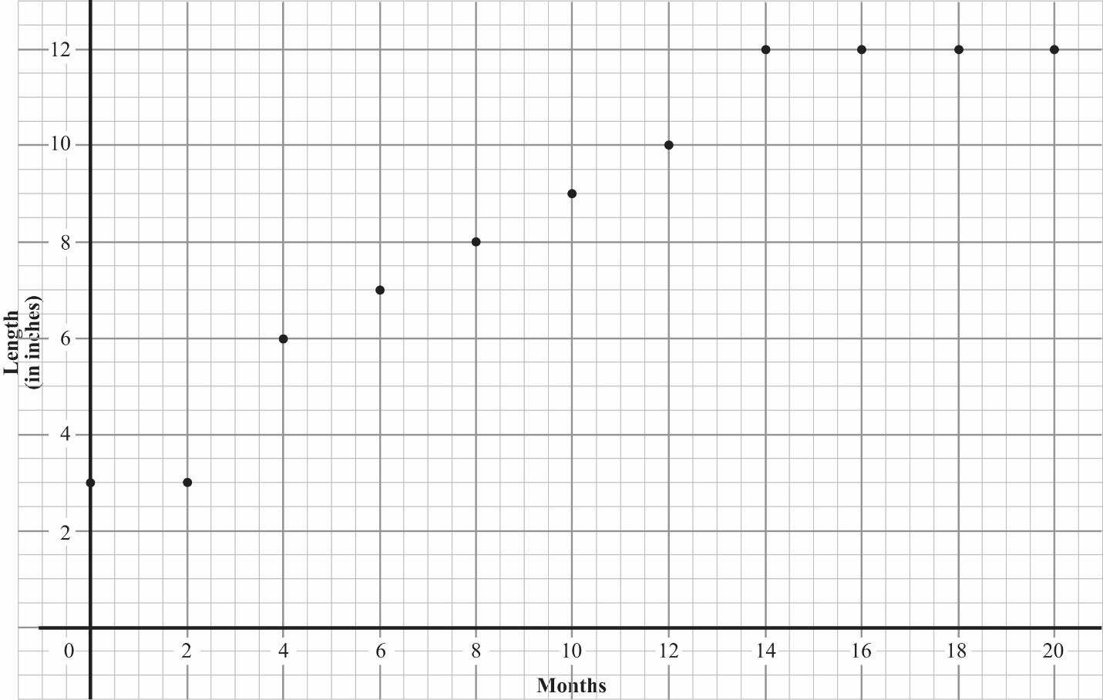

Student work may look different depending on their chosen scale.

- How many inches did the meerkat grow between month 6 and month 18?
The meerkat grew 5 inches between months 6 and 18.
- How many months did it take for the meerkat to grow from 7 inches to 12 inches?
It took 8 months for the meerkat to grow from 7 inches to 12 inches.
- Decide whether the meerkat grew more from month 0 to month 10 or from month 10 to month 20. Explain your answer.
The meerkat grew more from months 0–10 than it did from months 10–20. The meerkat grew 6 inches from months 0-10 and 3 inches from months 10-20.

For more on the Major Work of the grade, see achievethecore.org/focus.
Although the individual content standards in domain 5.NBT don’t mention word problems, the standards in grades K-4 do invest strongly in word problems, which can be reasonably taken to imply that students should be able to integrate the problem solving skills they learned in previous grades with their increasing computational skill in grade 5.

